**PROJECT TOPIC: DexVPN**

**Group No. :61**

**Project Group Members:**

1. Karan Singh Sikarwar (2342010305) **2.** Kunjan Chaudhary (2342010342)
2. Lalit Kumar Badhotiya (2342010350) **4.** Lokendra Dixit (2342010354)

**5.** Gaurav Singh Sisodia (2342010218)

**Project Supervisor:** Dr. Anuj Mangal

**About the Project:** DexVPN is a mobile-based Virtual Private Network (VPN) application designed to provide secure and private internet access. Built using React Native, DexVPN offers a seamless and user-friendly experience for Android and iOS users. The app allows users to connect to VPN servers across multiple locations, ensuring online privacy and data protection. DexVPN dynamically fetches available server locations through a free API, enabling users to select and connect to their preferred region effortlessly.

With a simple interface, users can toggle the VPN connection and switch locations without hassle. The project is designed to function without a backend server, relying entirely on free APIs for VPN connectivity. DexVPN aims to deliver a minimalistic yet effective solution for secure browsing, protecting user data from cyber threats, ISPs, and other prying eyes. This project is developed as a college initiative, focusing on providing a functional and lightweight VPN solution.

**Motivation:** The scope of DexVPN extends to providing a secure and private internet experience for mobile users without requiring a backend server. As a major project, it involves implementing real-time API integration, secure network protocols, and seamless cross-platform functionality using React Native. DexVPN is beneficial to society by ensuring online privacy, protecting user data from cyber threats, and enabling unrestricted access to information. Its innovation lies in its backend-free approach, making it lightweight, cost-effective, and easily accessible to users without requiring server hosting. This project showcases expertise in mobile app development, API integration, and cybersecurity, making it a strong candidate for a final-year project.

### Project Planning: 1. Research & Planning (Jan 2025 - Mid Jan 2025)

* Define project goals, requirements, and expected outcomes.
* Research existing VPN solutions and available free APIs.
* Finalize the tech stack (**React Native**, free VPN API, etc.).

**2. Learning React Native (Mid Jan 2025 - End Jan 2025)**

* Strengthen knowledge of React Native, TypeScript, and API integration.
* Explore libraries for navigation, UI components, and network handling.

**3. UI/UX Design (Late Jan 2025 - Early Feb 2025)**

* Design wireframes and UI layout for the app.
* Ensure a **minimalistic** and **user-friendly** interface.
* Front-End structure (https://excalidraw.com/#json=z0_IT1_FahxTWkJQXHjrY,w9R-TvBM1hcaNT61l5pvPQ)

**4. API Research & Integration (Feb 2025 - Late Feb 2025)**

* Identify and test free VPN APIs.
* Implement API calls to fetch server locations dynamically.

**5. Frontend Development (Mid Feb 2025 - Mid Mar 2025)**

* Develop core screens like **VPNHomePage.tsx** and **LocationScreen.tsx**.
* Implement navigation, settings, and location selection.

**6. VPN Connectivity Implementation (Mar 2025 - Late Mar 2025)**

* Integrate VPN toggle functionality with API.
* Ensure smooth connectivity and disconnection features.

**7. Testing & Debugging (Late Mar 2025 - Mid Apr 2025)**

* Fix bugs

**8. Final Deployment (Early Apr 2025 - End Apr 2025)**

* Prepare the final build for deployment.

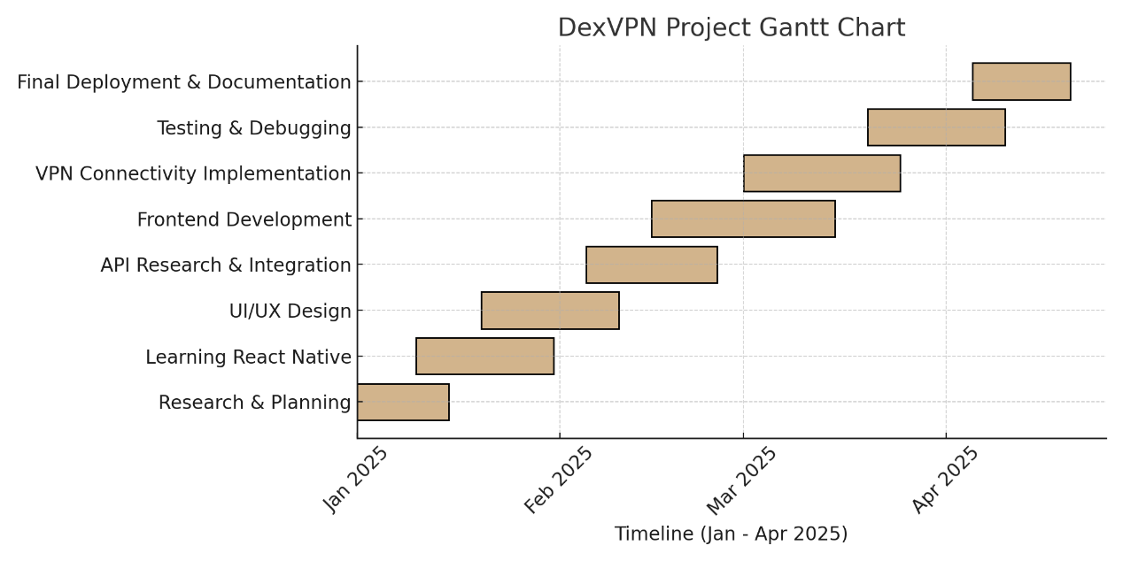

**Tools required:**

* **Hardware Requirements:** Laptop or workstation as a development environment and A android device (version 7.0 ) minimum for live debugging
* **Software Requirements:** Code Editor , Node.js , Android Studio tools

**Signature of Project Supervisor: _____________________**